

Power BI Reverse Smart Connector

User Guide

Version 1.0

# 

Table of Contents

1. Introduction 3

1.1 Overview 3

1.2 Scope 3

1.3 Supported Versions 3

1.4 Supported Operating Systems 3

2. Connector Features 3

2.1 Automatic Code Export 3

2.2 Mapping Creation 3

2.2.1 Business Rules 3

2.2.2 Extended Properties 4

2.2.3 Source Extract SQL 4

2.3 Mind Map Creation in Business Glossary Manager 4

2.4 Metadata Sync up 4

3. Using the Connector 4

3.1 Pre-Requisites 4

3.2 Connector Options 6

3.3 Configuring the Connector 7

3.4 Running the Connector 7

1. Introduction
   1. Overview

The Power BI Reverse Smart Connector is used to reverse engineer Power BI reports and create mappings and mind map in Erwin Data Intelligence Suite (DIS). The Connector creates the mappings for SQL queries under individual logical tables present in the Power BI report.

The connector uses the .pbit and .pbix files as input and analyses them to generate mappings and mind map in Erwin Data Intelligence Suites Mapping Manager and Business Glossary Manager, respectively. Every report available in the package file will have a corresponding mapping in the Mapping manager and have corresponding mind map in Business Glossary Manager.

* 1. Scope
* The Connector requires the Power BI reports in .pbix and .pbit formats.
* The exported folder should contain report information for the connector to create mappings and mind map successfully.
* The Connector only pulls Power BI files information from the input files.
  1. Supported Versions

All Power BI versions

* 1. Supported Operating Systems

Windows

# 

1. Connector Features
   1. Automatic Code Export

* Automated folder Export using “Power BI Report Export” Smart Connector based on Power BI Folder & Repository (to be updated)
* Note: This is a separate connector.
  1. Mapping Creation
* The Connector can handle multiple Power BI files in a single run and to create mappings in Erwin DIS
* Mappings are created in DIS based on the Report Name and Pages present in it. Every report will have a dedicated mapping under a subject area named after the .pbix file it uses, under that it create mappings with names of pages.
  + 1. Business Rules
* Any expressions used in the Power BI Report either at the report level or the Model Level are captured in the Mapping under the Business Rule Column
  + 1. Extended Properties

The Mapping extended properties contain information on the deployed Power BI folder used as a source to the Power BI report.

* + 1. Source Extract SQL

This is having the query participated in the creation of mapping.

* 1. Mind Map Creation in Business Glossary Manager

The Connector also supports creation of mind map in Business Glossary Manager feature, where it creates association business asset objects and make association and also creates Metadata for the logical tables available in respective Power BI report and associate them with the mind map, So that it will visualize the overall logical tables and columns available in the Power BI report.

* 1. Metadata Sync up

The Connector also supports a Metadata Sync up feature, where the mappings generated will be synced with the metadata information available in Erwin Metadata Manager based on the System and Environment values.

1. Using the Connector
   1. Pre-Requisites

* Deploy the WAR file in the Tomcat

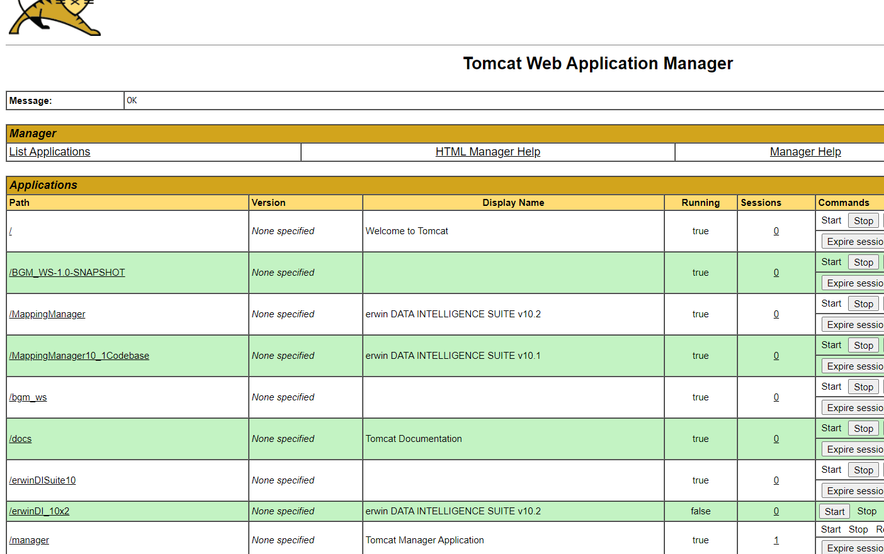

* Deploy the .jar files in the EMM library from the given jar files as shown in the below image.
* The folder path is:

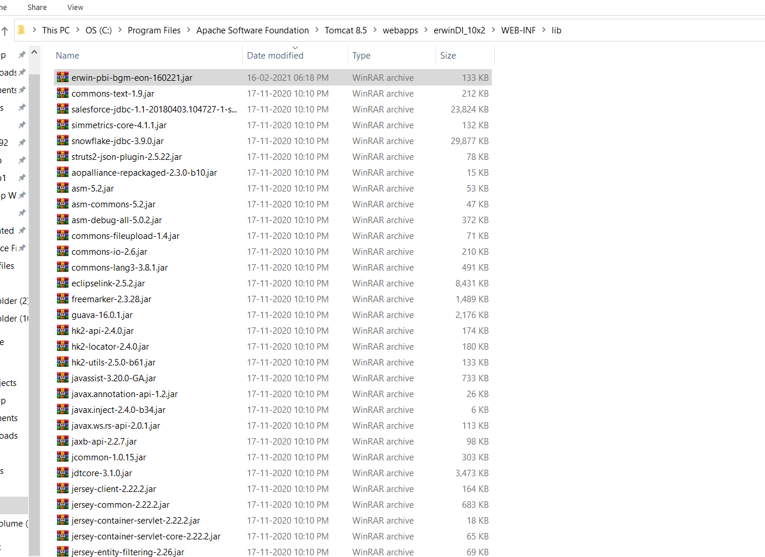**<Tomcat Location>\Apache Software Foundation\Tomcat 8.5\webapps\ErwinDI\WEB-INF\lib**

* The Power BI file provided as input should contain information on the objects used to build the report.
* The Power BI file should be copied from the Power BI project Directory and not be exported from the Power BI Framework Manager.
* The input files must be placed in a directory on the DIS server in a location which the user has access to.
* The input package files must contain report information for the connector to run successfully.
* Metadata should be available in Erwin Mapping Manager for Metadata Sync up to work.
  1. Connector Options

The connector provides following options which can also be updated at run time. The Power BI Reverse connector provides the following options:

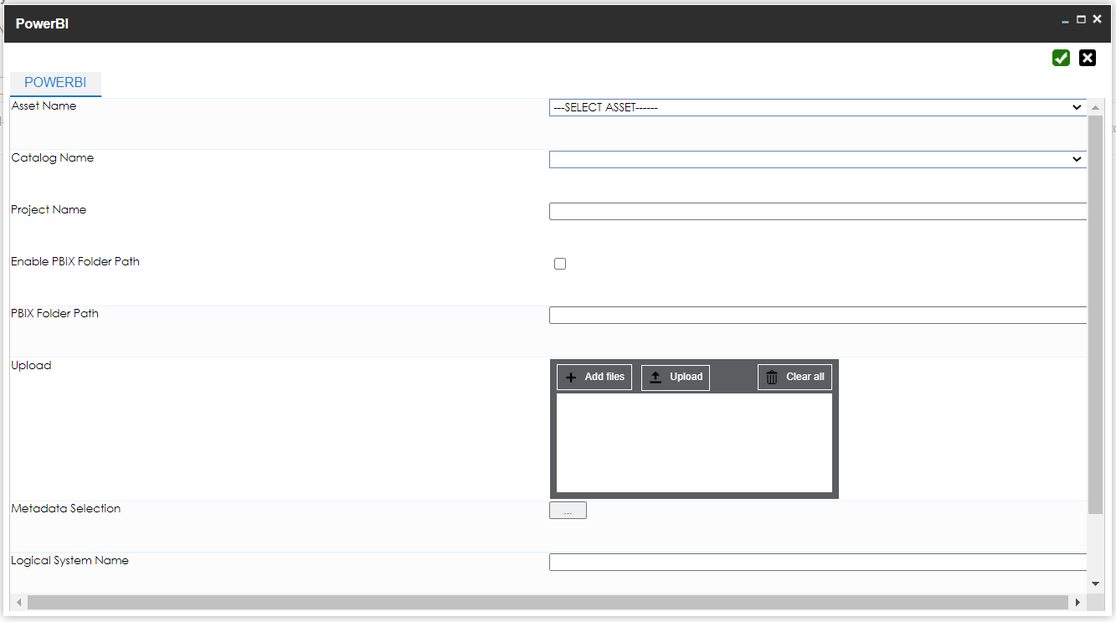

Fig: Power BI Reverse Connector Options

|  |  |
| --- | --- |
| * **Asset Name** | This selection box contains all the Business Assets available in the Business Glossary Manager. |
| * **Catalog Name** | This selection box reflects all the catalogs available under the selected Business Asset. |
| * **Project Name** | This field should contain the project name under which the Mapping should create. If the project is not available, then our connector will create the projects according to the name provided in the field. |
| * **Enable PBIX Folder Path** | Need to choose input file option either File path or Upload files |
| * **Pbix Folder path** | This field should contain the directory path to the Power BI .pbix file. |
| * **Upload** | In this field need to upload pbix files |
| * **Logical System Name** | field should contain the name under which the the logical table for the corresponding Power BI report will create. |

* 1. Configuring the Connector
* 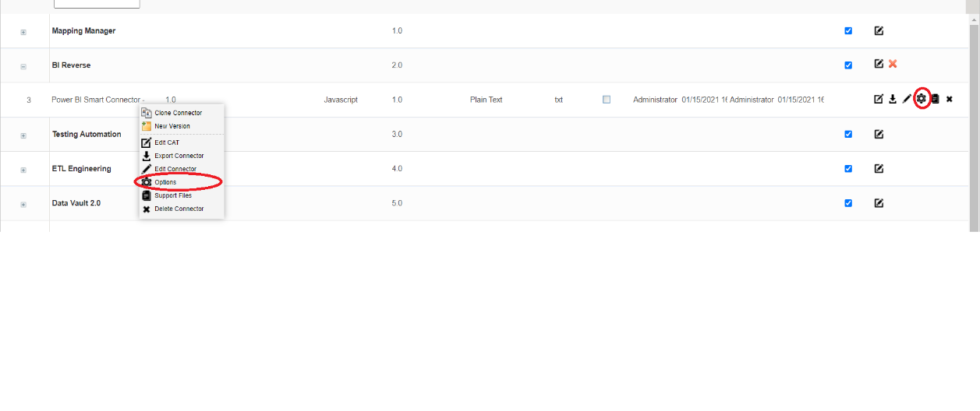The field details for the connector can be updated by right clicking on the connector and clicking on “Options”, or by clicking on the gear icon under the Options column alongside the connector name.
* The values specified in these fields determine the URL of the ***BGM_WS-1.0-SNAPSHOT*** WAR deployed in the tomcat and directory paths which the connector will use to pick the input files.
* The Project Name field can contain the name of the Project to be used to create the mappings in. In case an existing project is not available, the connector will create a new project .
* All the above fields can also be edited at runtime.
* Remember to click on the save button after making any updates to the Connector options.
  1. Running the Connector

The connector can be executed by following the steps below:

* Right click on the Project node in DIS Mapping Manager and click on “Run Template”.

­ 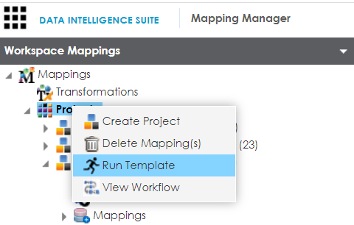

* 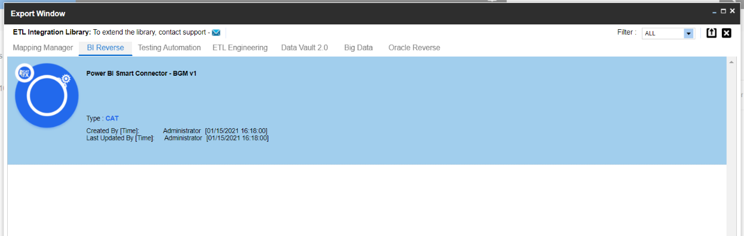On the next pop up window Navigate to the Tab “BI Reverse engineering ” and locate the connector “Power BI Reverse engineering v2.1” in the Connector List and click on “Export”.

* On the next pop up window, enter the required in the text fields as per the field descriptions in the section “3.2 Connector Options”.
* Select the Asset Name and Catalog Name for Business Glossary.

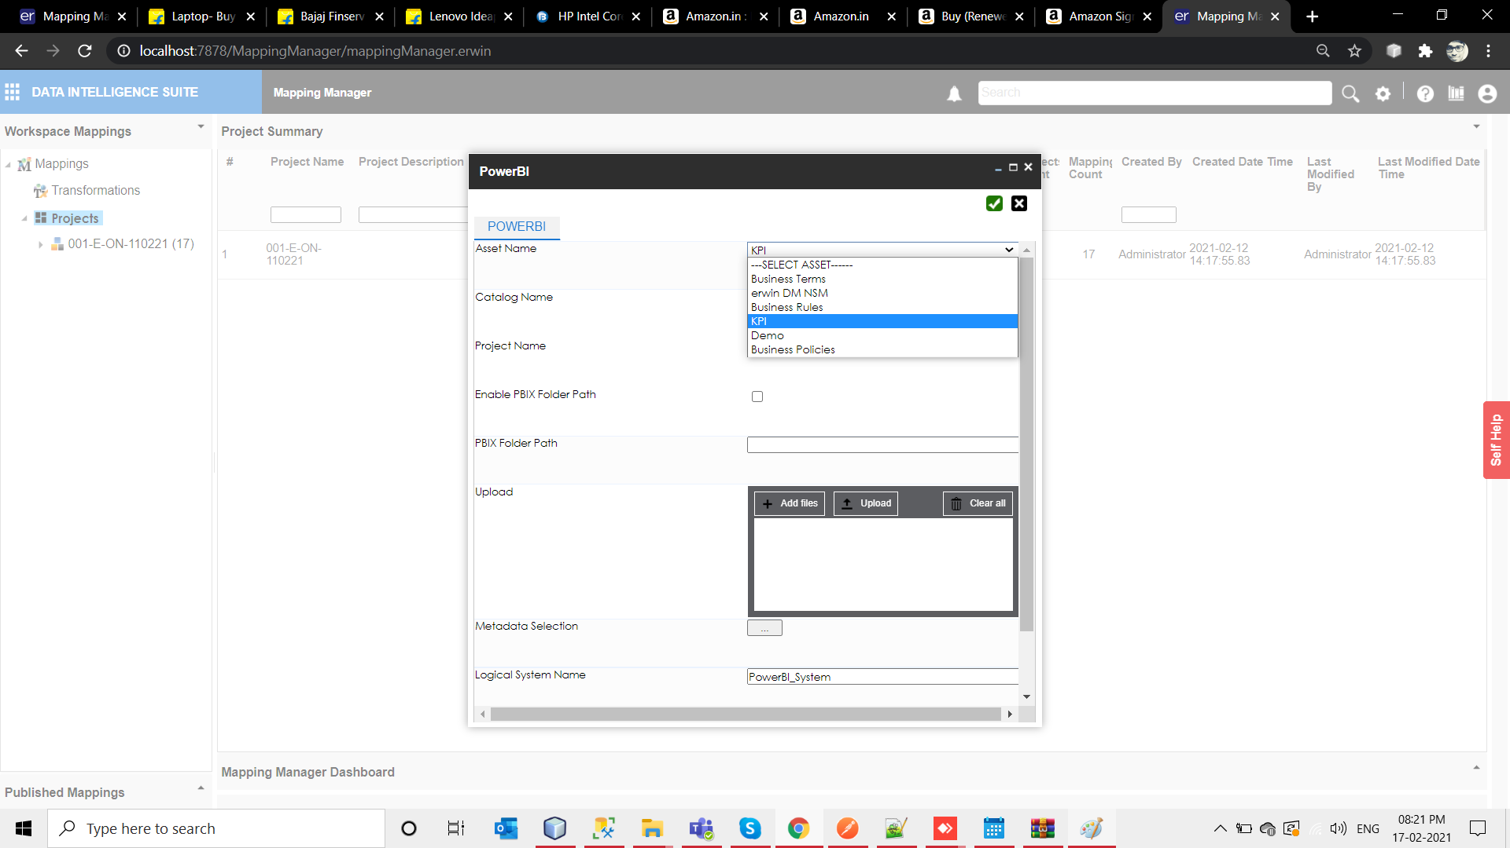 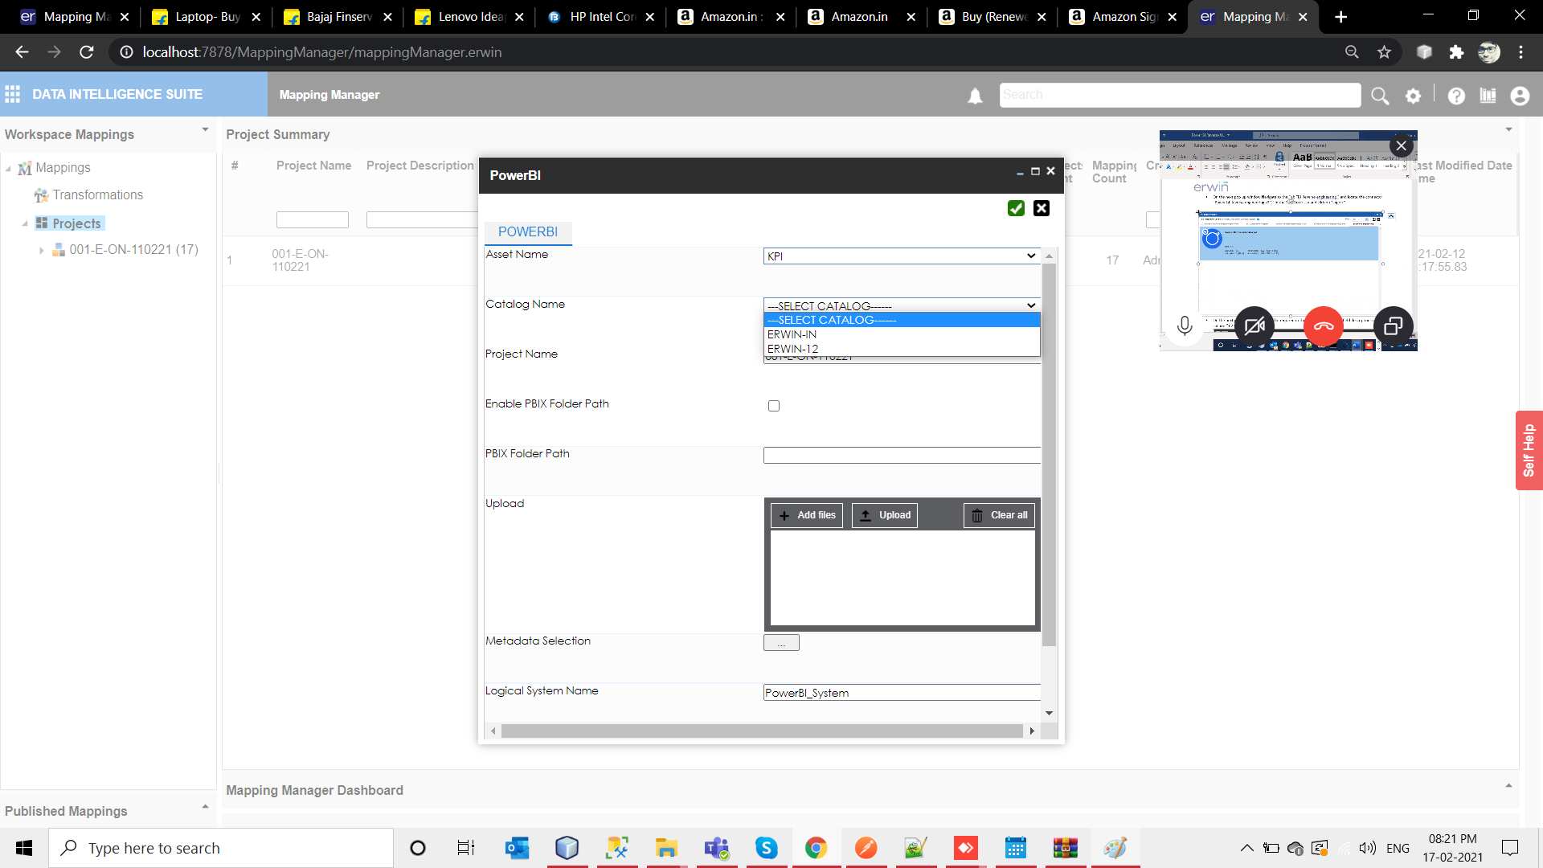

* Click on the green box in the top right corner to run the connector.

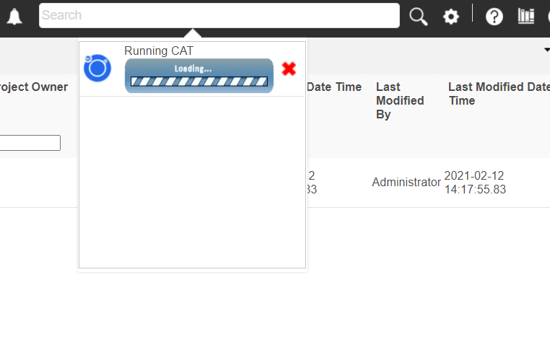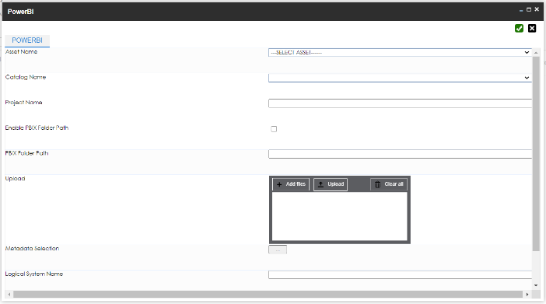

* Once the connector finishes execution, it provides a “Download File” option in the notifications pane.

This file will contain an information log on the mappings created/updated in DIS Mapping Manager.

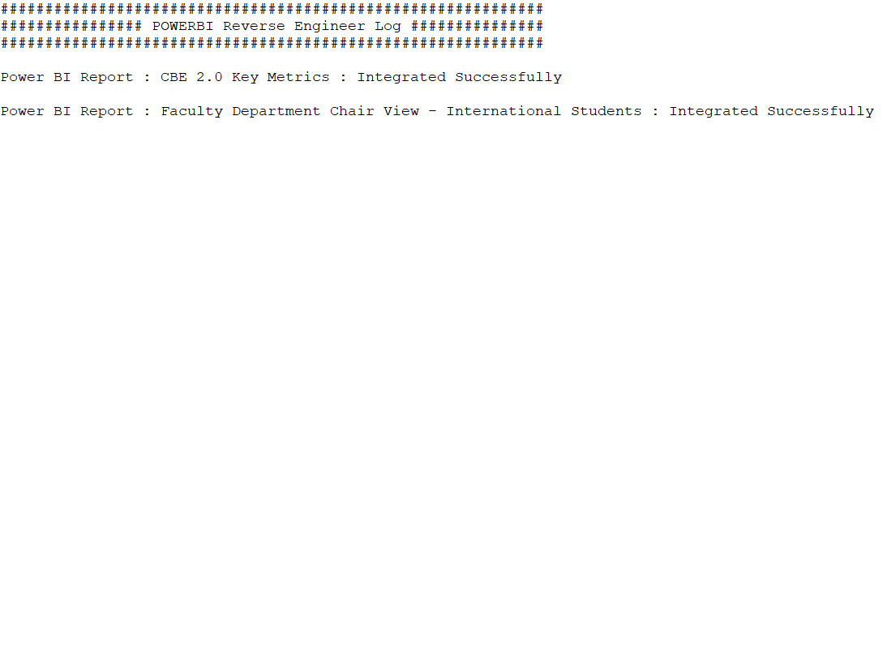

* 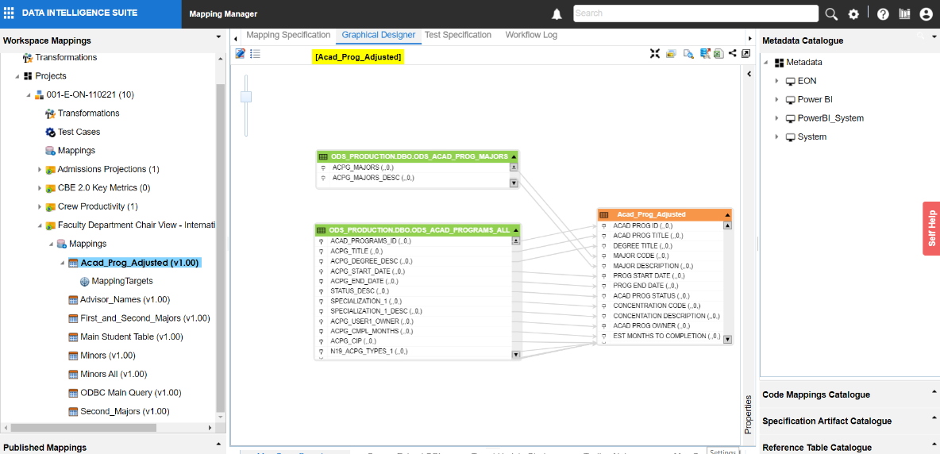Refresh the browser window and under the Mapping Manager module, check for the project created on the left-hand side of the page under the Projects Node and verify if the mappings are created.
* And open the Business Glossary Manager and expand the Asset and Catalog you selected while running the ACP to get the mind map.

